Tab 1
- Briefly explain Dynamic Black-Box Testing.

- An e-commerce system is built to handle the trading of computer accessories. The system processes 200000 transactions each week. The system is required to produce an analysis report according to the standard provided. Suggest the types of tests that are important for the system.

- Compare Volume Test, Stress Test, Load Test, and Performance Test

- In what situation would an Exploratory Test can be applied? Explain your answer.

- Differentiate Alpha Testing and Beta Testing.

- What is Error Guessing?

- Give examples of common errors that can be guessed by using Error Guessing by the experienced testers.

- When is Error Guessing most useful?

- A web application is developed to determine the loyalty types of a club member. If the member stays in the club less than 12 months, the member will be awarded as Normal grade, VIP grade will be awarded to whom has become member between 1 to 3 years. VVIP grade is for those members who stay more than 3 years.

Decide and apply appropriate Black Box Testing techniques to determine the number of test cases. You must show the detailed working.

Boundary Point | Test Values (x) | Expected Result
Lower Limit | 0 | Normal
1 Year Transition | 11 | Normal
 | 12 | VIP
 | 13 | VIP
3 Year Transition | 35 | VIP
 | 36 | VIP
 | 37 | VVIP

Parameter | Equivalence Classes | Representative Value | Result
Membership Duration (x) | vEC1: 0 < x <1 | 0.5 | Normal
 | vEC2: 1 <= x <= 3 | 2 | VIP
 | vEC3: 3 < x <= 120 | 65 | VVIP
 | ivEC1: x <= 0 | -20 | Error (Invalid)
 | ivEC2: x is unrealistic value | 150 | Error (Invalid)

Parameter | Equivalence Classes | Representative Value | Result
Membership Duration (x) | vEC1: 0 < x <1 | 0.5 | Normal
 | vEC2: 1 <= x <= 3 | 2 | VIP
 | vEC3: x > 3 | 65 | VVIP
 | ivEC1: x <= 0 | -20 | Error (Invalid)
 | ivEC2: x > 120 | 150 | Error (Invalid)

Test Cases
TC1: Test with valid value for Normal member. Input value (test value) is 0.5
TC2: Test with valid value for VIP member. Input value (test value) is 2
TC3: Test with valid value for VVIP member. Input value (test value) is 65
TC4: Test with invalid value for error case. Input value (test value) is -20
TC5: Test with invalid value for error case with unrealistic value. Input value (test value) is 200

Identify and list the test case using Boundary Value Analysis

Equivalence Class | Invalid (-min) | Valid (min, +min, max, -max) | Invalid (+max)
vEC1: 0 < x < 12 | 0 | 1 , 2 , 11 , 10 | 12
vEC2: 12 <= x <= 36 | 11 | 12 , 13 , 36 , 35 | 37
vEC3: 36 < x <= 780 | 35 | 37, 38 , 780 , 779 | 781

Assumption:
- Assume that the maximum accepted value number years of membership is 65 years
- All duration values (in years) converted to months

answer

Tutorial 5
- Briefly explain Dynamic Black-Box Testing.
- Testers view the components or system as a black box.
- Does not concerned on the internal behavior and structure of the software.
- Test case derived from system specification.
- Regardless to the software design or codes.
- Test the functionality and features of the software.
- GOAL: Find areas wherein the program does not behave according to its specifications.
- Refer to slide 3
- Test the system, components by executing the codes.
- Thus, required input values and observing results.
- Creation of test cases.
- Black Box and White Box dynamic test

- An e-commerce system is built to handle the trading of computer accessories. The system processes 200000 transactions each week. The system is required to produce an analysis report according to the standard provided. Suggest the types of tests that are important for the system.
Performance testing evaluates how well the e-commerce system handles high volumes of transactions and produces reports efficiently. It involves load testing to simulate normal transaction levels, stress testing to identify limits under peak loads, and measuring response time and throughput. Performance testing is important because it ensures the system can process 200,000 weekly transactions reliably, maintains a smooth and fast user experience, guarantees timely and accurate report generation, and helps identify any bottlenecks in the system before they affect real users.
- Functional testing

- Compare Volume Test, Stress Test, Load Test, and Performance Test
Volume test – for further info, refer https://www.softwaretestinghelp.com/what-is-volume-testing/

Volume Test
- Tests the system with a very large amount of data in the database.
- To check how the system handles large data volumes and whether performance is affected
Stress Test
- Tests the system beyond its normal capacity by increasing users or transactions until it fails.
- To determine the system's breaking point and how it behaves under extreme conditions
Load Test
- Tests the system with a large number of users or transactions that represent expected usage.
- To check if the system can handle normal or peak workload without performance issues.
Performance Test
- Measures how fast and stable the system performs under normal conditions.
- To ensure the system meets performance requirements such as response time and throughput.

- In what situation would an Exploratory Test can be applied? Explain your answer.
Exploratory testing can be applied when testers need to explore the software to understand how it works and identify defects without predefined test cases. It is commonly used when requirements are unclear, when new features are introduced, or when testers want to discover unexpected system behavior. During exploratory testing, the tester actively interacts with the system, makes decisions about what to test next, and investigates potential issues within a limited time.
- Exploring, finding out about the software, what it does, what it doesn’t do, what works and what doesn’t work. The tester is constantly making decisions about what to test next and where to spend the (limited) time.
- Widely used in Agile model
- Early iteration is required
- The application is critical . Let say to be delivered in short period
- New tester would like to learn on the system
- When requirement is not completed or partially available

- Differentiate Alpha Testing and Beta Testing.
Alpha Testing
- Takes place at the developer’s site. Developers observe the users and record the problems.
- Testing of an application when development is about to complete. Minor design changes can still be made as a result of alpha testing.
- Typically performed by a group that is independent of the design team, but still within the company, e.g. in-house software test engineers, or software QA engineers.

Beta Testing
- Also known as field testing. It takes place at customer’s site.
- It sends the system to users who install it and use it under real-world working conditions.
- A beta test is the second phase of software testing in which a sampling of the intended audience assess the system.

Refer to slide 17-18

- What is Error Guessing?
Error guessing means testers predict potential defects based on past experiences.

Error-Guessing is a software testing technique where testers use their experience, intuition, and domain knowledge to predict potential defects in an application. Instead of following predefined test cases, testers intelligently anticipate areas prone to errors and design test cases accordingly.

- Give examples of common errors that can be guessed by using Error Guessing by the experienced testers.
Boundary-related issues (e.g., entering values just outside valid ranges).
Invalid input formats (e.g., letters in numeric fields, special characters in usernames).
Null or empty data handling (e.g., submitting forms without required fields).
Logical flaws (e.g., incorrect date calculations, leap year errors, division by zero).
User action errors (e.g., double-clicking buttons, refreshing during transactions).
Configuration mistakes (e.g., missing files, incorrect paths).
Security oversights (e.g., SQL injection, weak password validation).
Compatibility issues (e.g., browser or device differences).

Login Page: Entering invalid username/passwords, SQL injection attempts, blank fields
Form Submission: Submitting without required fields, special characters in input fields
File Upload Feature: Uploading large files, unsupported formats, corrupted files

- When is Error Guessing most useful?
Requirements and specifications are not available.
Requirements are inadequate or unclear.
Limited knowledge of the software product exists.
Time constraints prevent a structured approach.
It is most useful during exploratory testing or when time is limited and critical bugs need to be found quickly.

- A web application is developed to determine the loyalty types of a club member. If the member stays in the club less than 12 months, the member will be awarded as Normal grade, VIP grade will be awarded to whom has become member between 1 to 3 years. VVIP grade is for those members who stay more than 3 years.

Decide and apply appropriate Black Box Testing techniques to determine the number of test cases. You must show the detailed working.

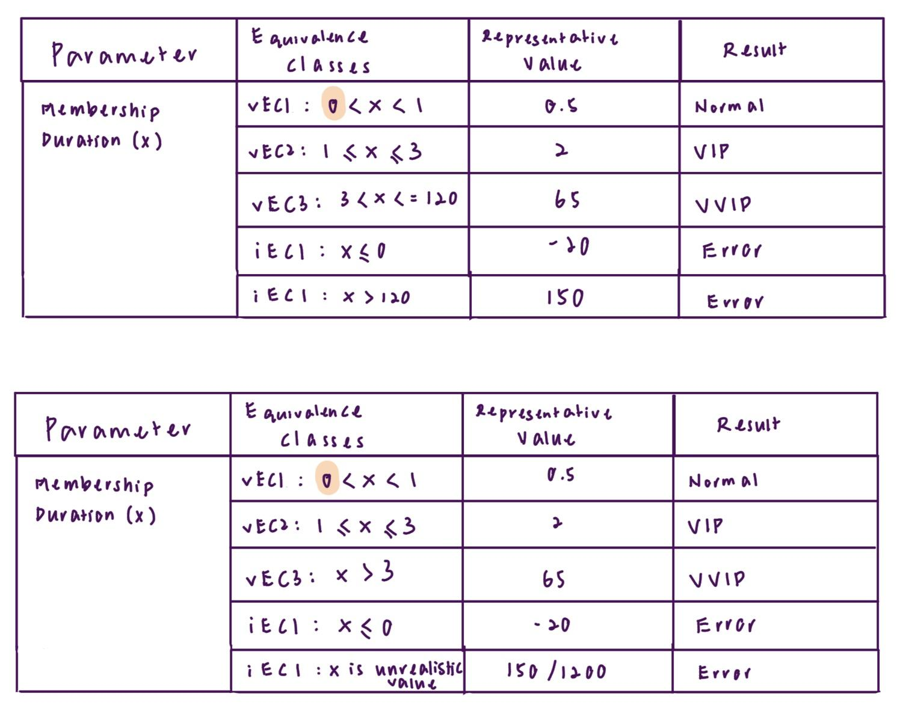
Test cases
TC1: Test with valid value for Normal member. Input value (test value) is 0.5
TC2: Test with valid value for VIP member. Input value (test value) is 2.
TC3: Test with valid value for VVIP member. Input value (test value) is 65.
TC4: Test with invalid value for error case. Input value (test value) is -20.
TC5: Test with invalid value for error case with unrealistic value. Input value (test value) is 200.

10. A special machine is used to check and categorise the sumo wrestler contestant, there are three classes that a man can choose to join. The machine will check on the weight of the contestant. For the Heavyweight class, the man must have at least 254 lbs and above. For Middleweight, the weight of the wrestler must be between 188 lbs and 253 lbs. If a man’s weight is 187 lbs and below, he can join the Lightweight class.

- Using Equivalence Class Partitioning, create a table to determine the equivalence class, representative value, parameter and expected result.

Parameter | Equivalence class | Representative value | Result
Sumo wrestler contestant weight (x) | vEC1: ≤187 | 100 | Lightweight
 | vEC2:188 ≤ x ≤ 253 | 200 | Middleweight
 | vEC3: ≥ 254 | 300 | Heavyweight
 | iEC1: x ≤ 0 | -50 | Error

- Identify and list the test case using Boundary Value Analysis.

Equivalence class | Invalid (min -1) | Valid (min, +min, -max, max) | Invalid (max +1)
vEC1: ≤187 | 186 | 187 | 188
vEC2:188 ≤ x ≤ 253 | 187 | 190, 195, 200, 225 | 254
vEC3: ≥ 254 | 253 | 254 | 255

Test cases
TC1: Test with valid value for Lightweight contestants. Input value is (test value) 187.
TC2: Test with valid value for Middleweight contestants. Input value is (test value) 190, 195, 200, 225.
TC3: Test with valid value for Heavyweight contestants. Input value is (test value) 254.
TC4: Test with invalid value for Lightweight contestants. Input value is (test value) 186, 188.
TC5: Test with invalid value for Middleweight contestants. Input value is (test value) 187, 254.
TC6: Test with invalid value for Lightweight contestants. Input value is (test value) 253, 255.

11. In order for a student to graduate from a Bachelor Degree, the student must clear all payments before the final examination. The CGPA of the student to pass is at least 2.67 point and the student must fill in the feedback form before graduation. If the student does not fill in the feedback form, the student will be prohibited from graduating and the student will be requested to pay 50 dollar for additional charges.

a. Construct the Cause Effect Graph.
C1 - Student cleared all payments
C2 - CGPA is at least 2.67
C3 - Feedback form filled

E1 - Student allowed to graduate
E2 - Student prohibited from graduating
E3 - Additional charge $50 required

b. From the Cause Effect Graph, create a Decision Table.

Conditions/ Actions | TC1 | TC2 | TC3 | TC4
C1 - Student cleared all payments | T | T | T | F
C2 - CGPA is at least 2.67 | T | T | F | -
C3 - Feedback form filled | T | F | F | -
E1 - Student allowed to graduate | T | F | F | F
E2 - Student prohibited from graduating | F | T | T | T
E3 - Additional charge $50 required | F | T | F | F

12. AGV cinema in Malaysia has given free tickets or 50% discount to the public for the celebration of Independence Day. The cinema is using a ticket printing system to print the ticket. In order for the public who is eligible for the promotion, the person must show his Identity Card at the ticket counter. For those people who come along with his son/daughter, maximum 4 free tickets are given to each family. If the person does not come along with his son/daughter but with his wife/partner, a 50% discount is given to each ticket. For those elderly people whose age is 60 and above, free tickets will be given to them with the presence of their identity card.

- Construct the Cause Effect Graph.

C1 – Identity Card shown
C2 – Come with son/daughter
C3 – Come with wife/partner
C4 – Age ≥ 60

E1 – Free ticket (family with children, max 4)
E2 – 50% discount ticket
E3 – Free ticket for elderly

- From the Cause Effect Graph, create a Decision Table.

Conditions/ Actions | TC1 | TC2 | TC3 | TC4
C1 – Identity Card Shown | T | T | T | F
C2 – Come with son/daughter | T | F | F | -
C3 – Come with wife/partner | F | T | F | -
C4 – Age ≥ 60 | F | F | T | -
E1 – Free ticket (family with children, max 4) | T | F | F | F
E2 – 50% discount ticket | F | T | F
E3 – Free ticket for elderly | F | F | T

